4. Write a C program to find Fibonacci series without using Recursion

**Aim:** To write a C program to generate the Fibonacci series up to a given number of terms without using recursion.

**Algorithm**

1. Start the program.
2. Declare variables: n for number of terms, first = 0, second = 1, and next.
3. Read the value of n (number of terms to generate) from the user.
4. Print the first two terms (0 and 1).
5. Use a loop from 3 to n:
   * Compute next = first + second.
   * Print next.
   * Update values: first = second, second = next.
6. Stop the program.

**Program**

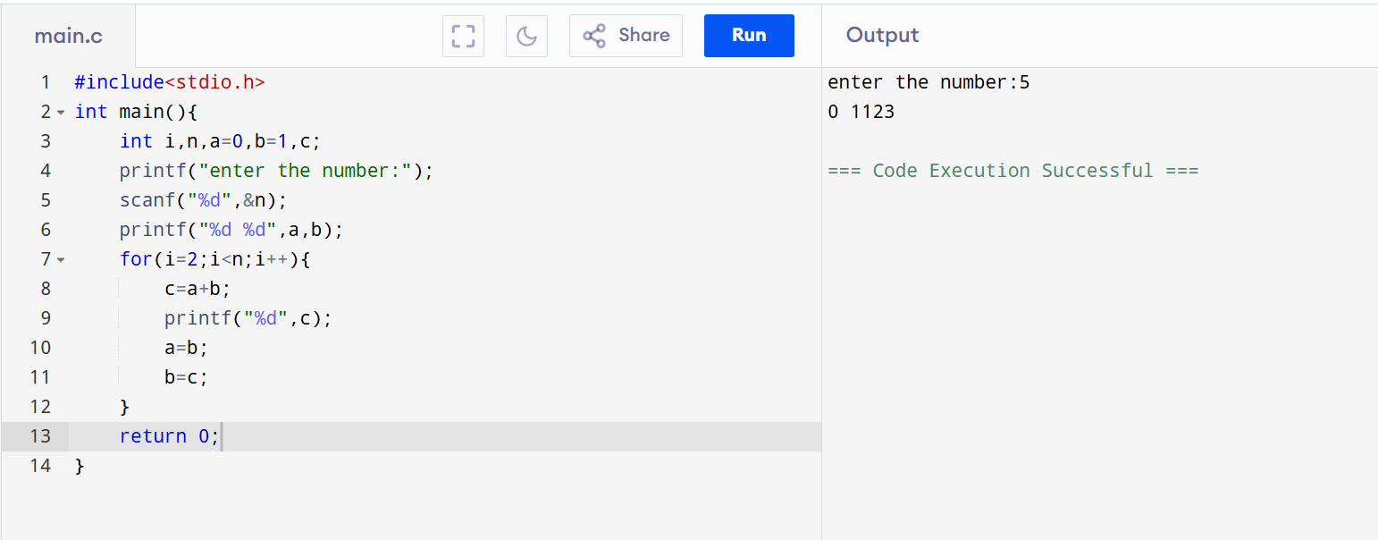

**Result:** Thus, the C program to generate the Fibonacci series without using recursion was successfully executed.